[Instant Test Driven Development with Java, JUnit and Mockito](https://ibm-learning.udemy.com/course/instant-test-driven-development-with-junit/)

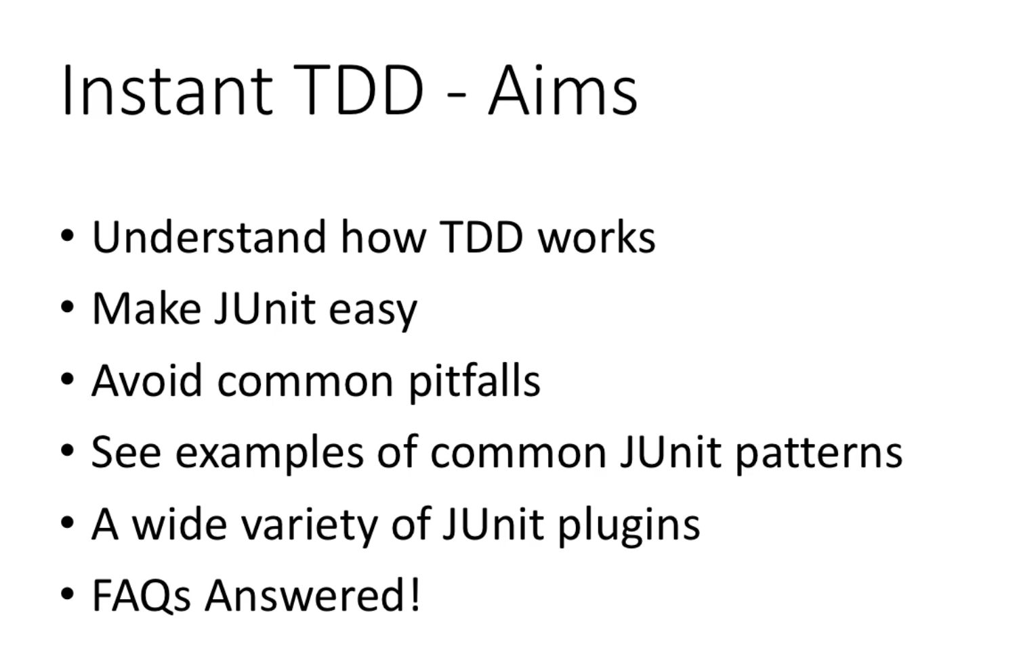

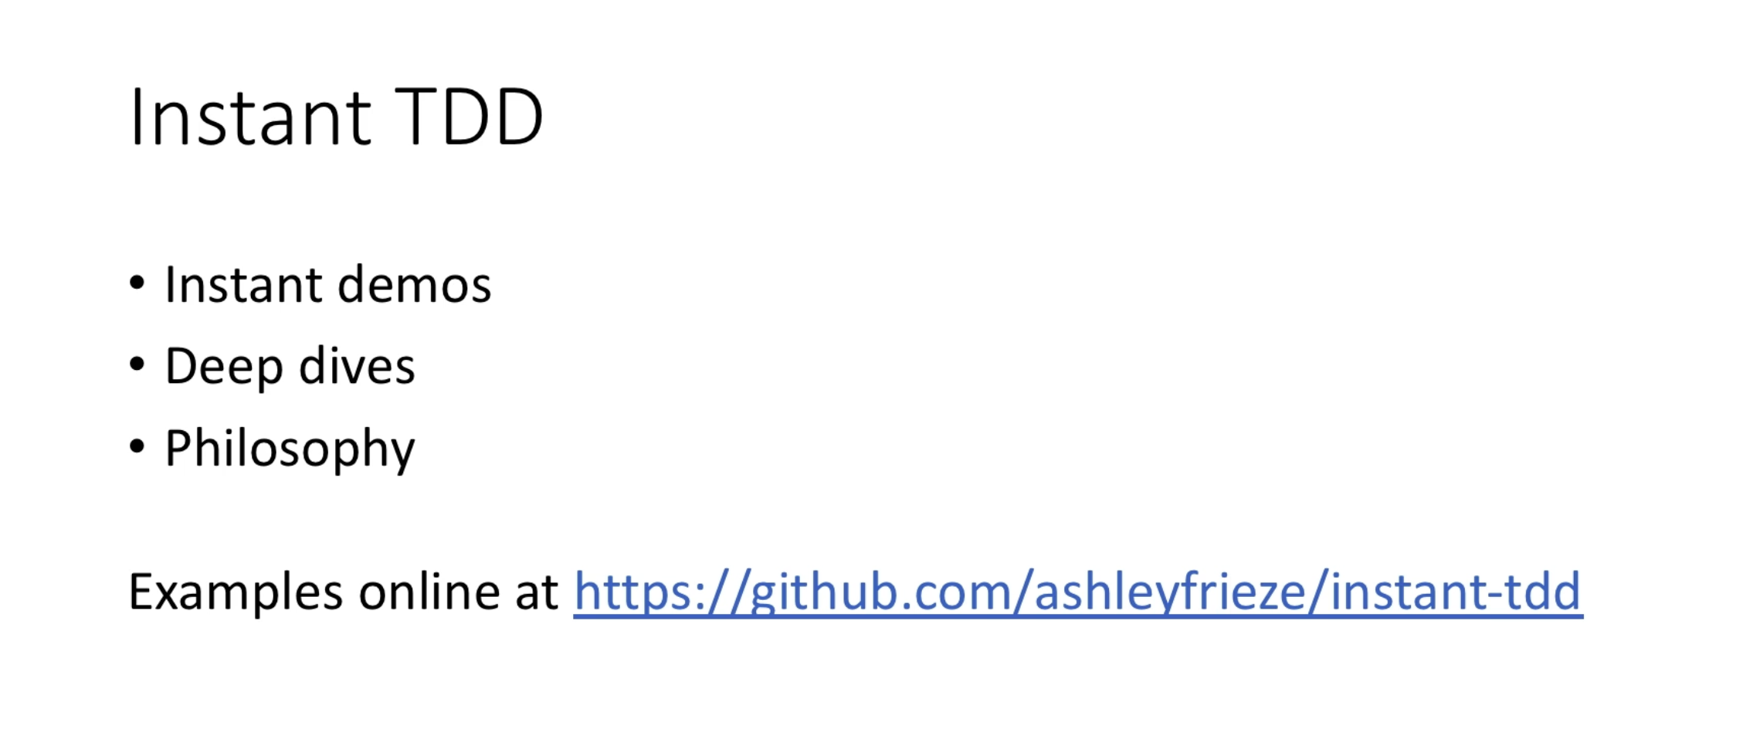

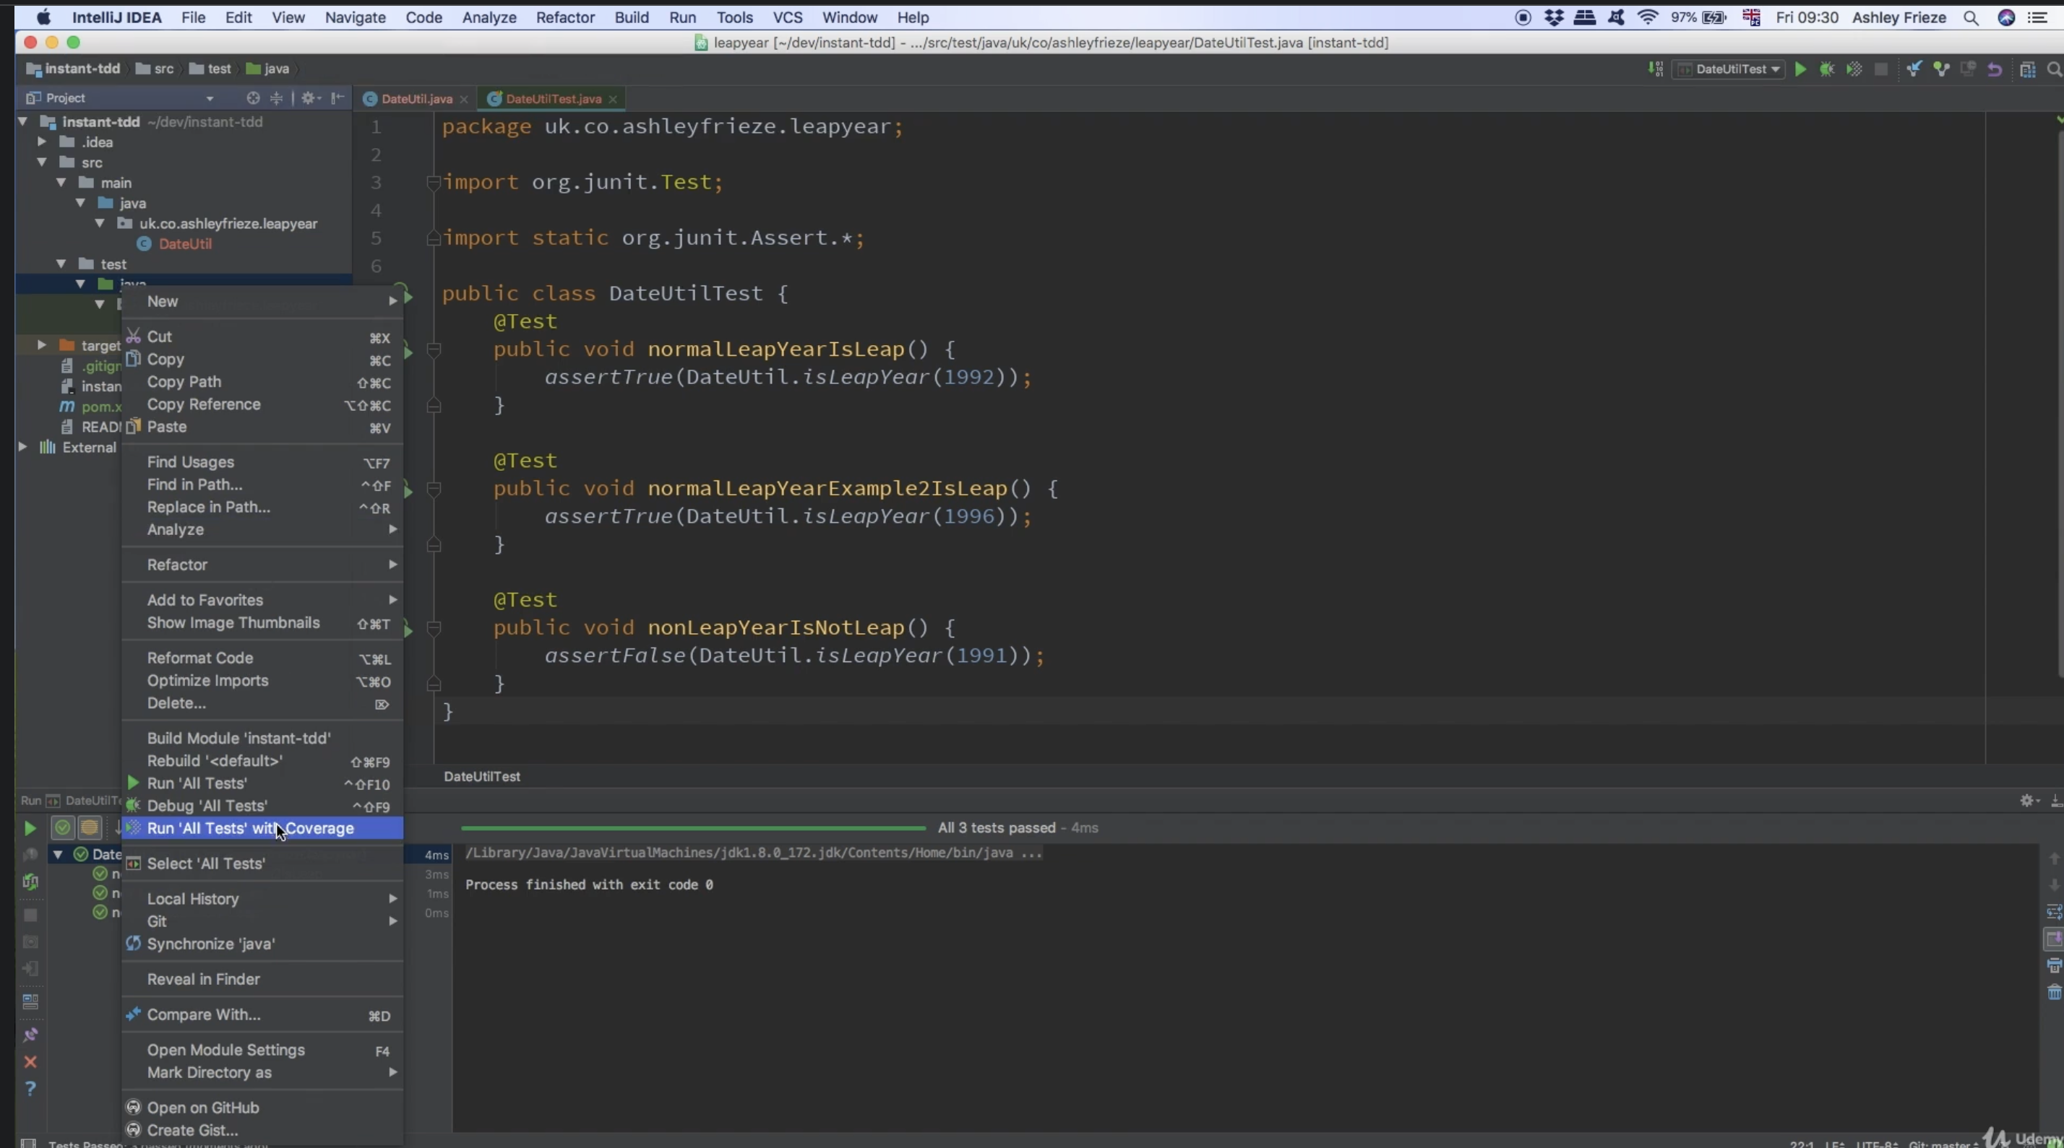

Amount of the code covered by unit testing can be calculated by “Running All Tests with Coverage”

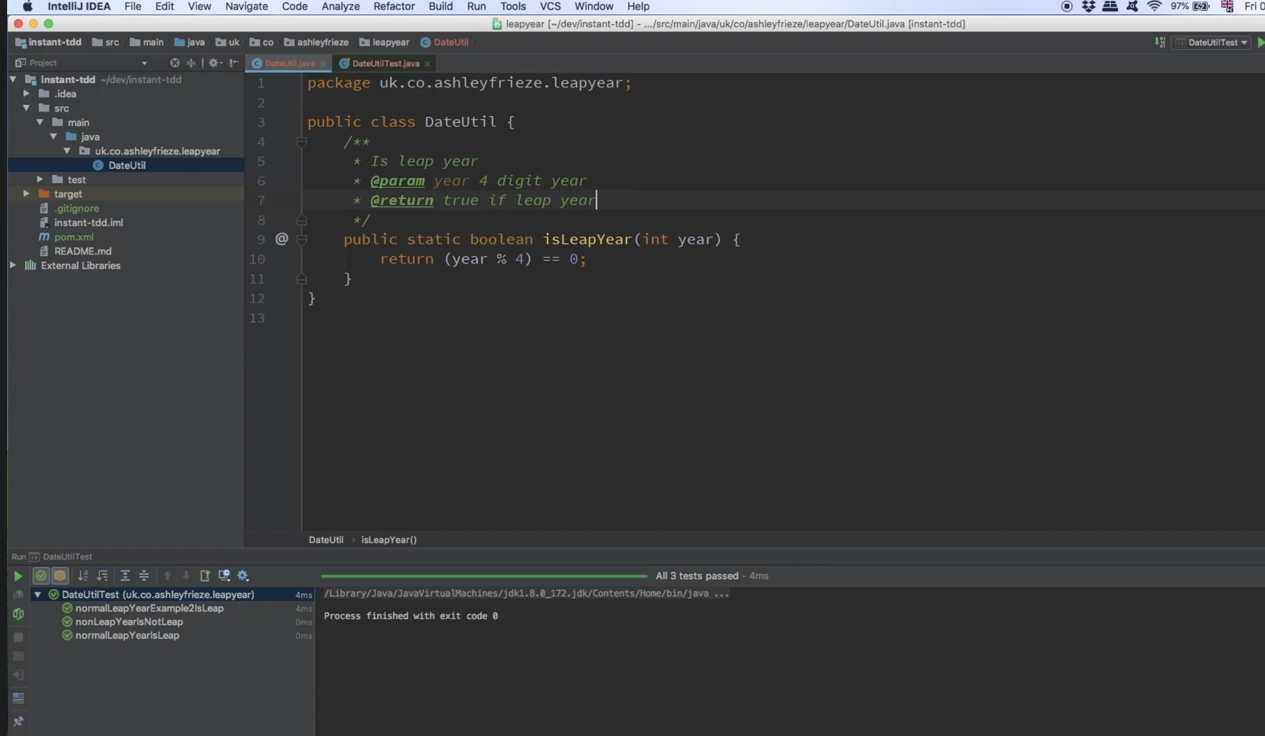

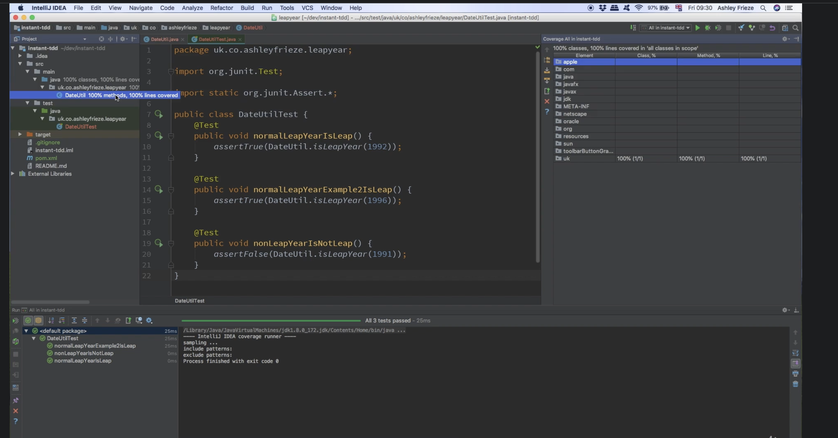

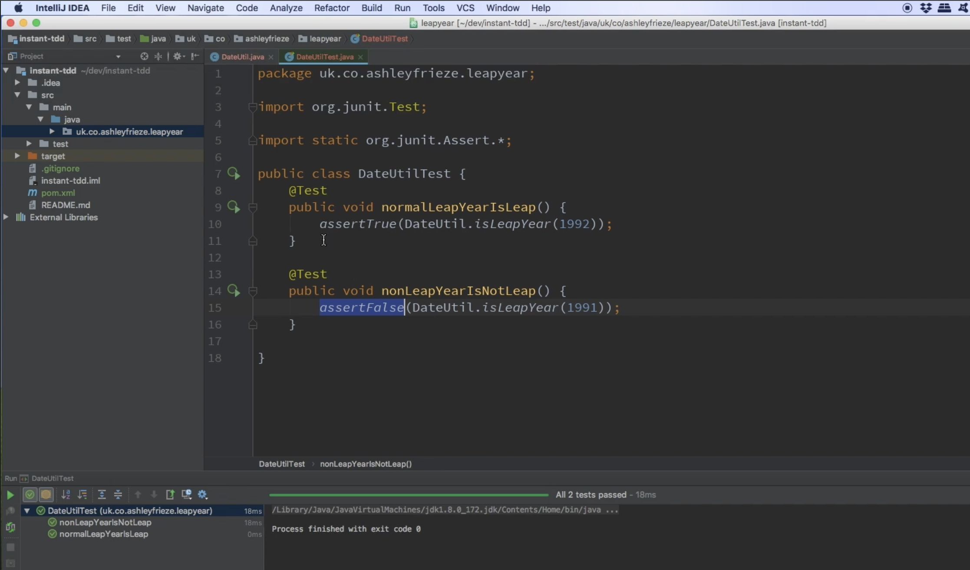

TDD

A unit test is created in the test folder of the same packages as Highlighted

And the Class name ends with Test

@Test annotations are used

It tells the Junit to run all the methods annoted as Test

And has import statements inorder to assert the test

It has assertions run on the inputs to make sure the expected results is obtained on running the on the code logic

The process of having multiple test is called as Triangulation

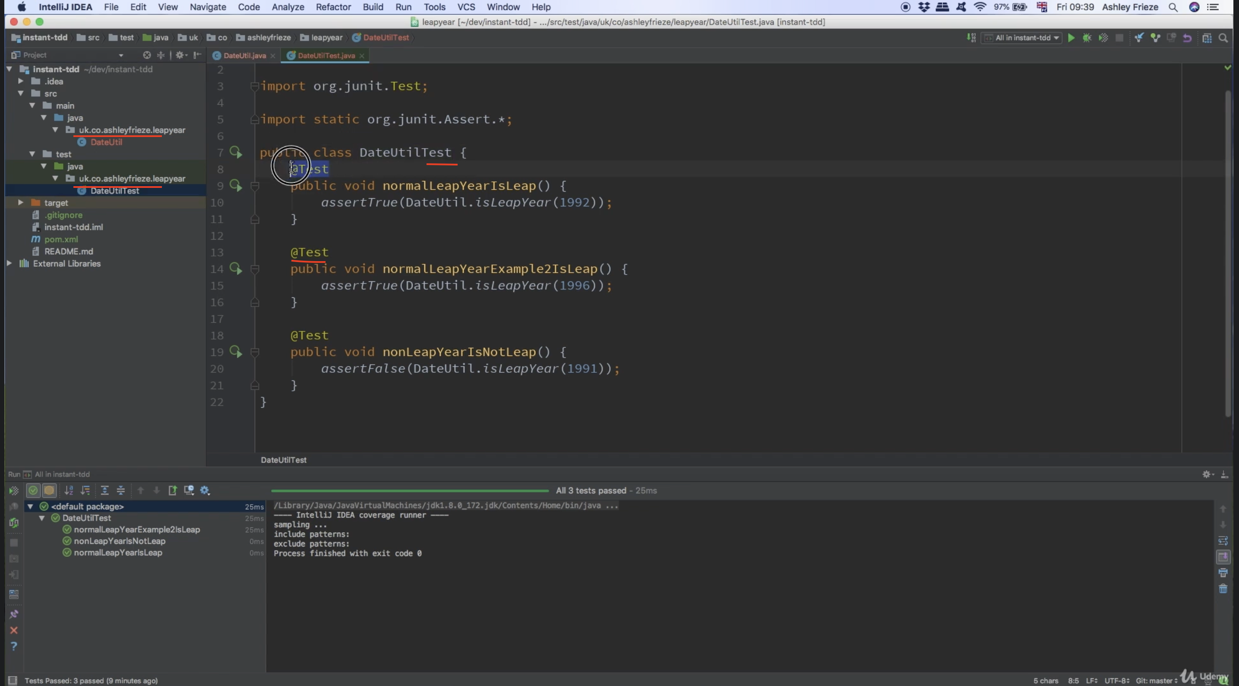

The test is able to execute only because of Junit External Libraries, it’s a maven project hence

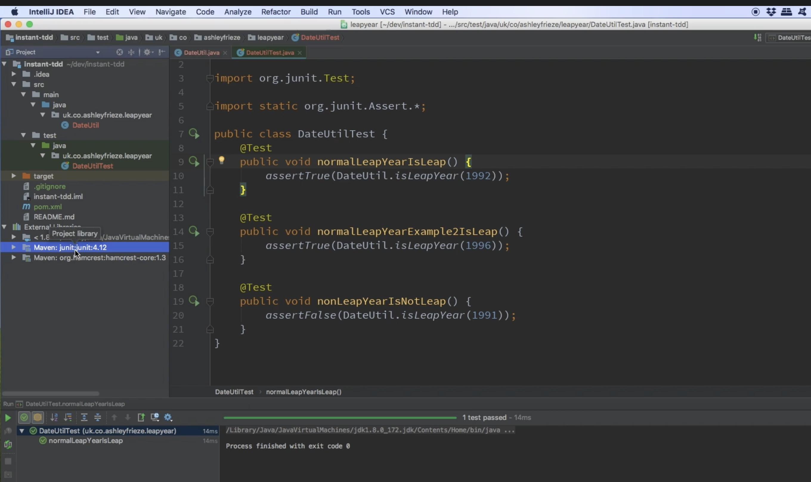

It’s a maven project hence the dependencies need to be added to pom.xml

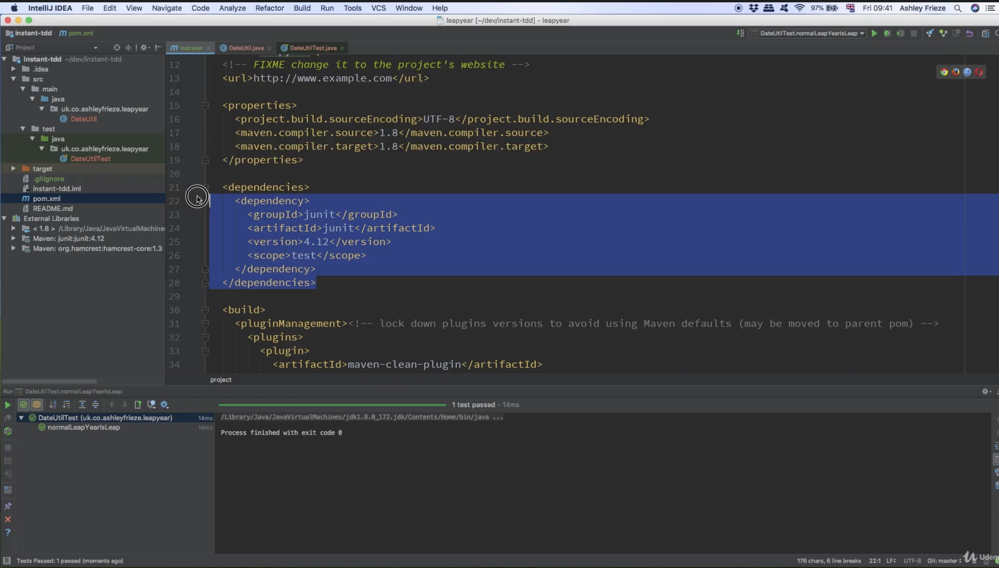

The IDE is using the Junit Librabries along with the test classes to do unit testinga

The code coverage Tool executes the test and watches for every single bit of logic in the code under test in order to determine how much of your code is tested

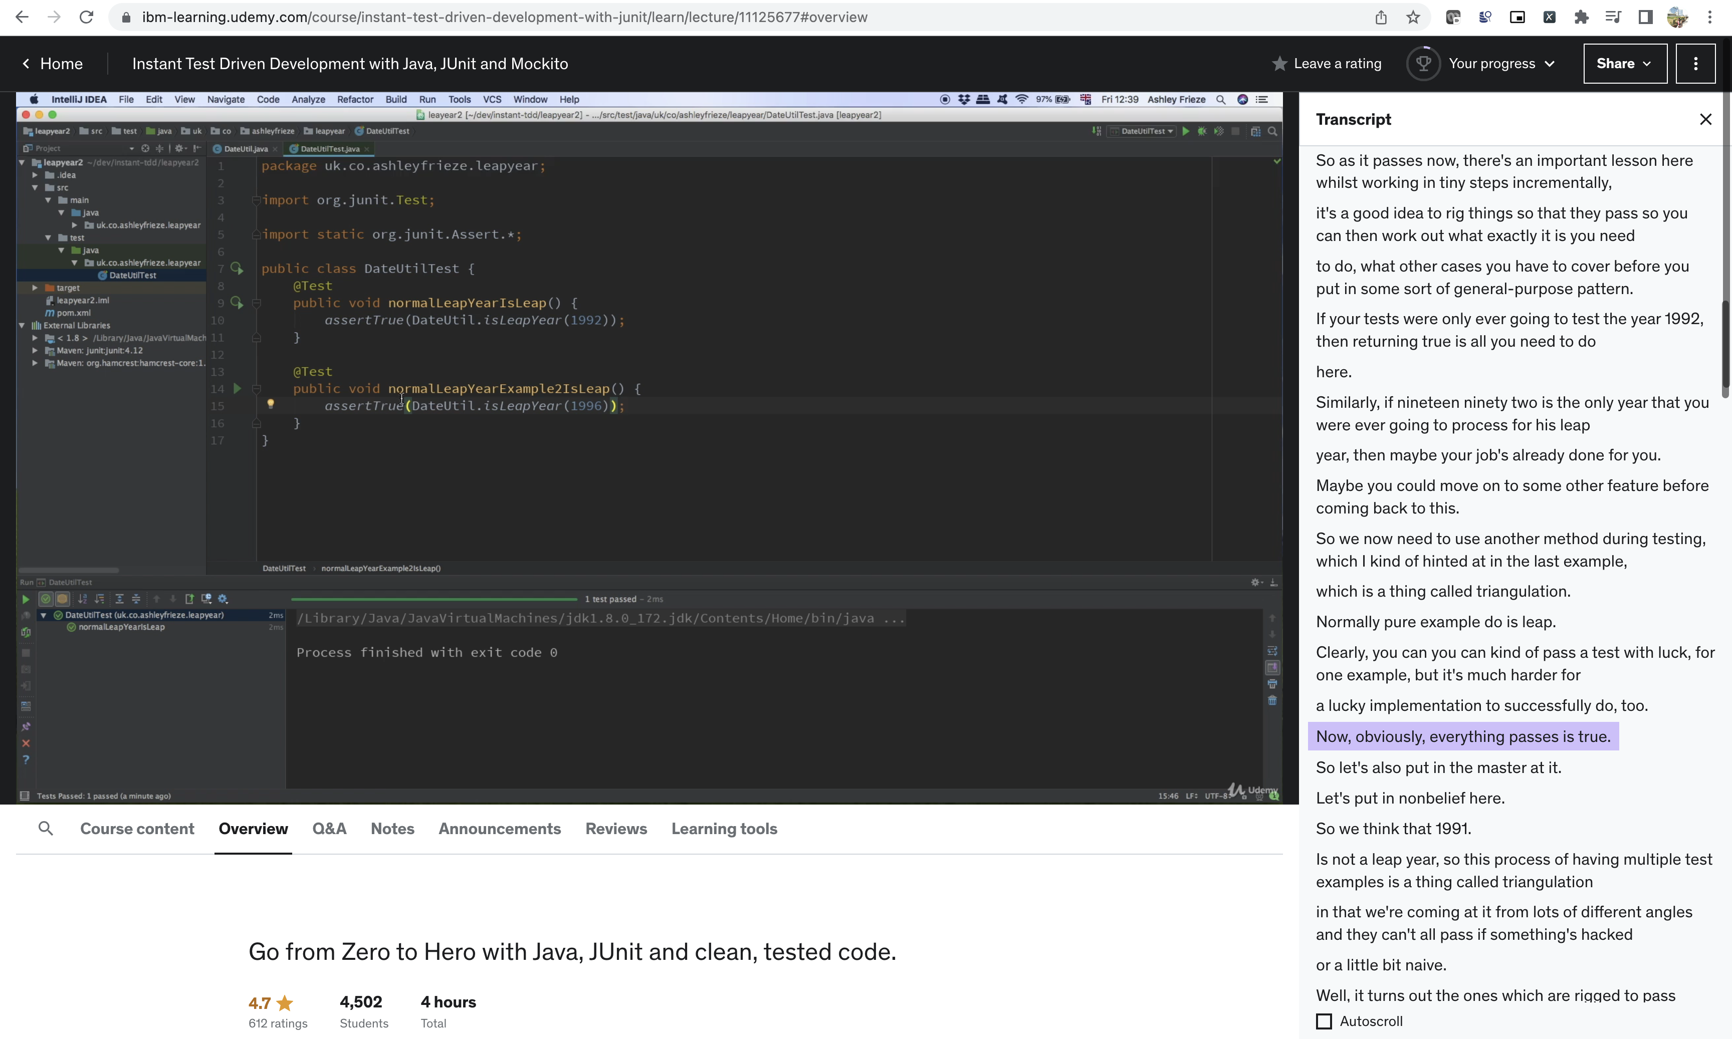

Triangulation

so this process of having multiple test examples is a thing called triangulation in that we're coming at it from lots of different angles and they can't all pass if something's hacked

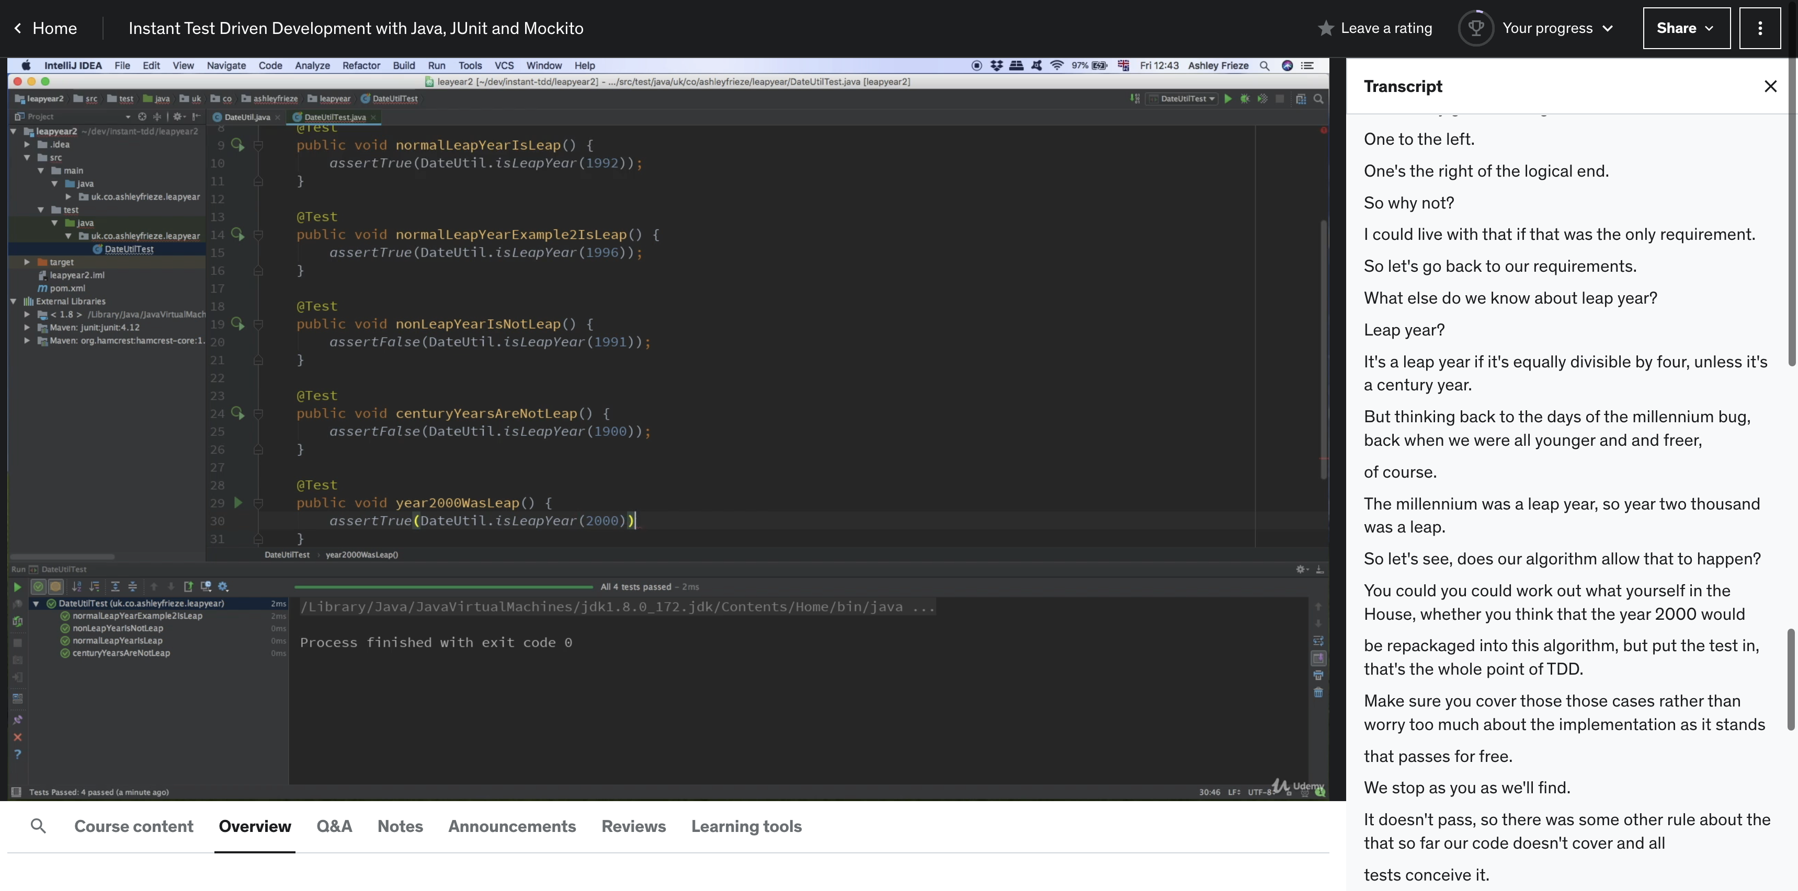

The code should not only be readable by computer but also by humans so using convention and making it nicer is necessary

Always think the below question

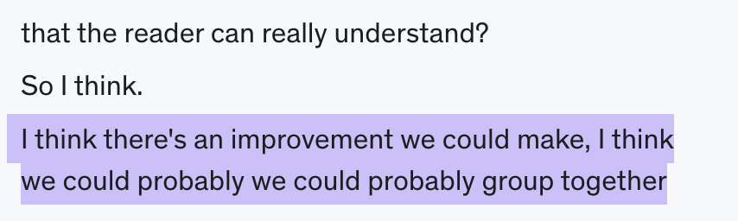

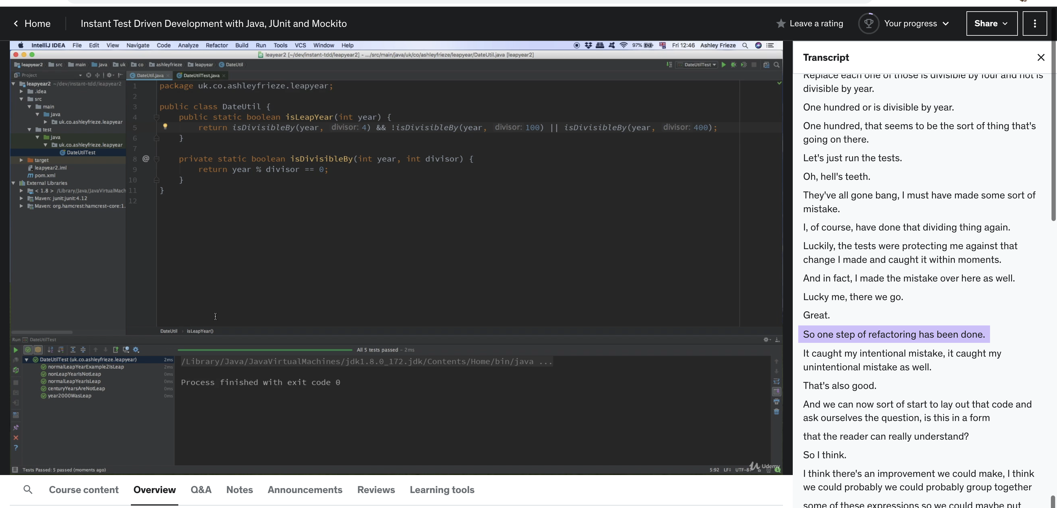

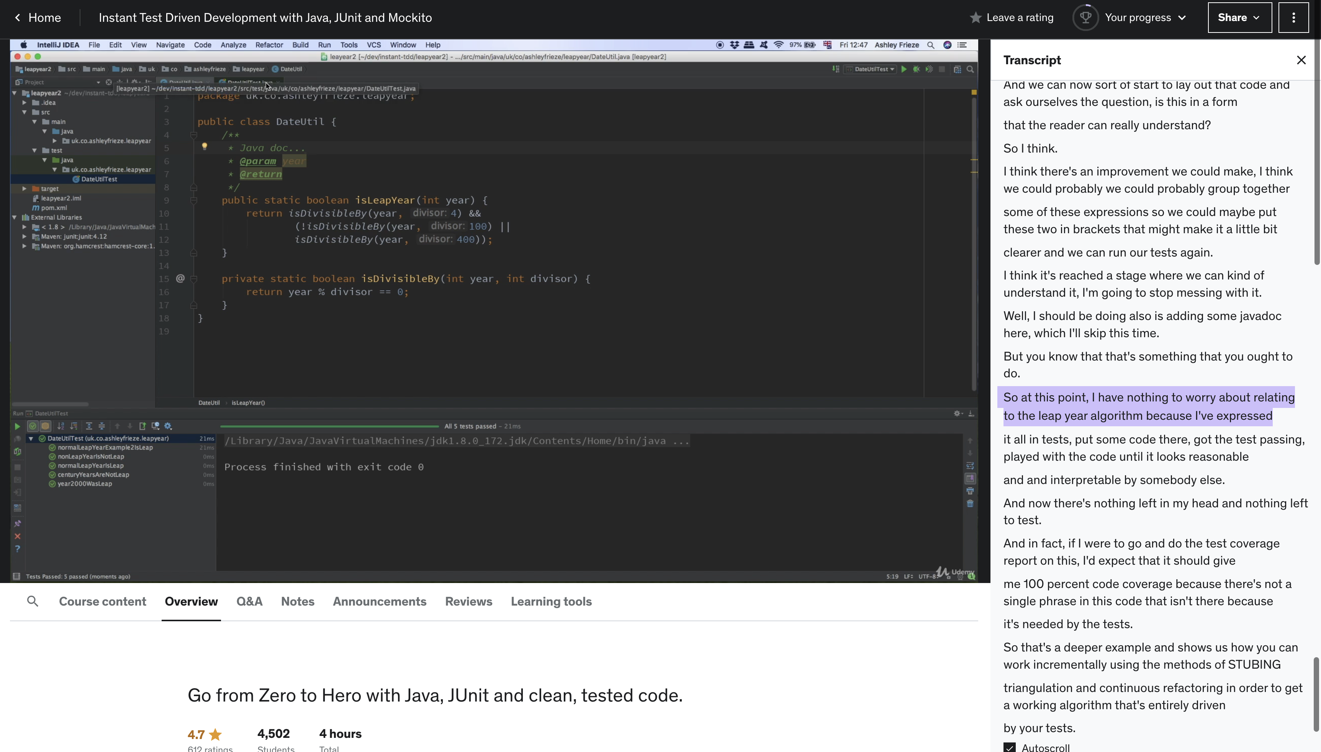

Always do the test coverage

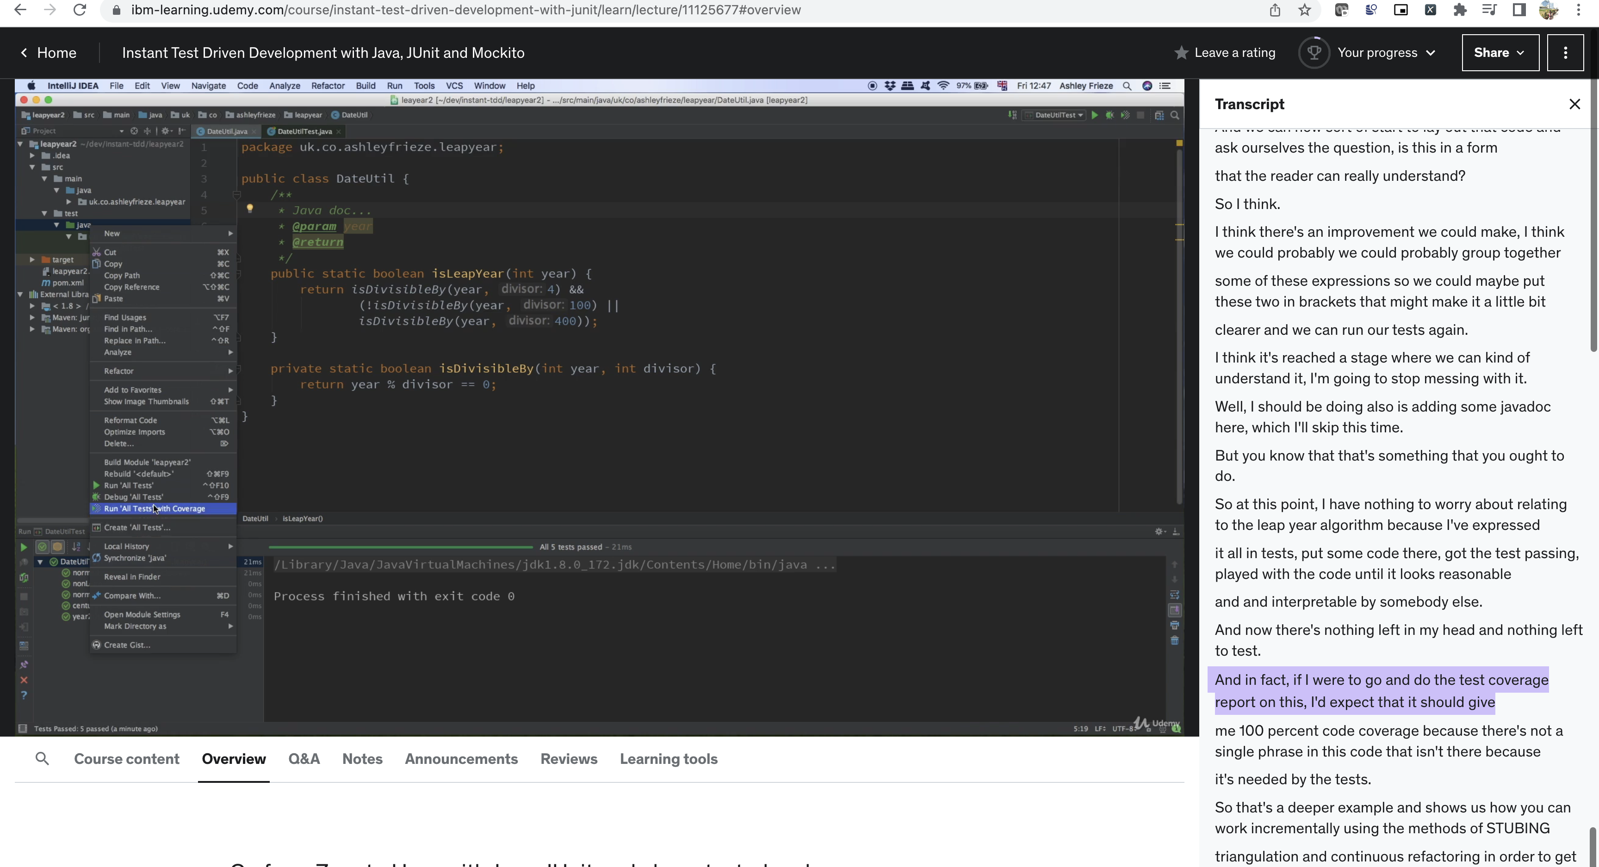

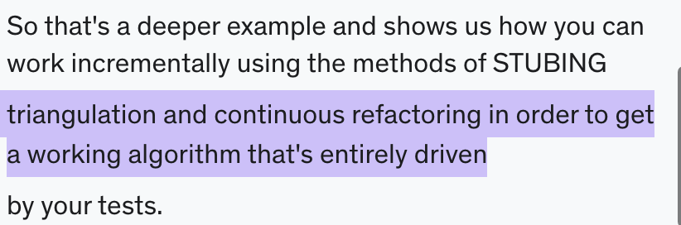

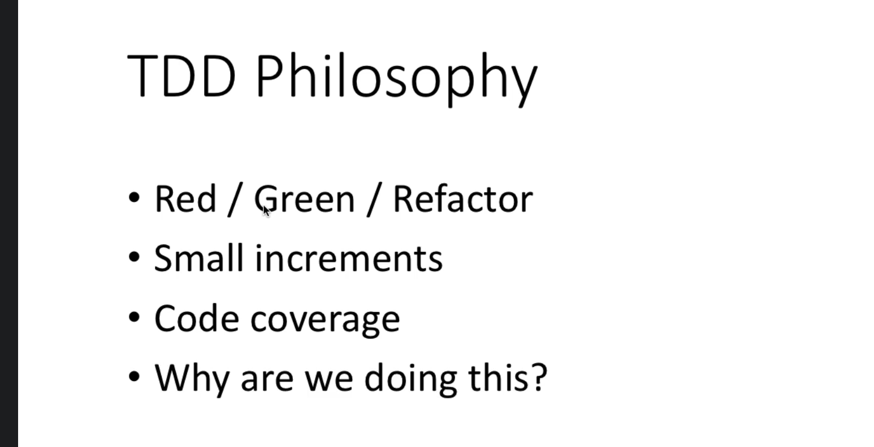

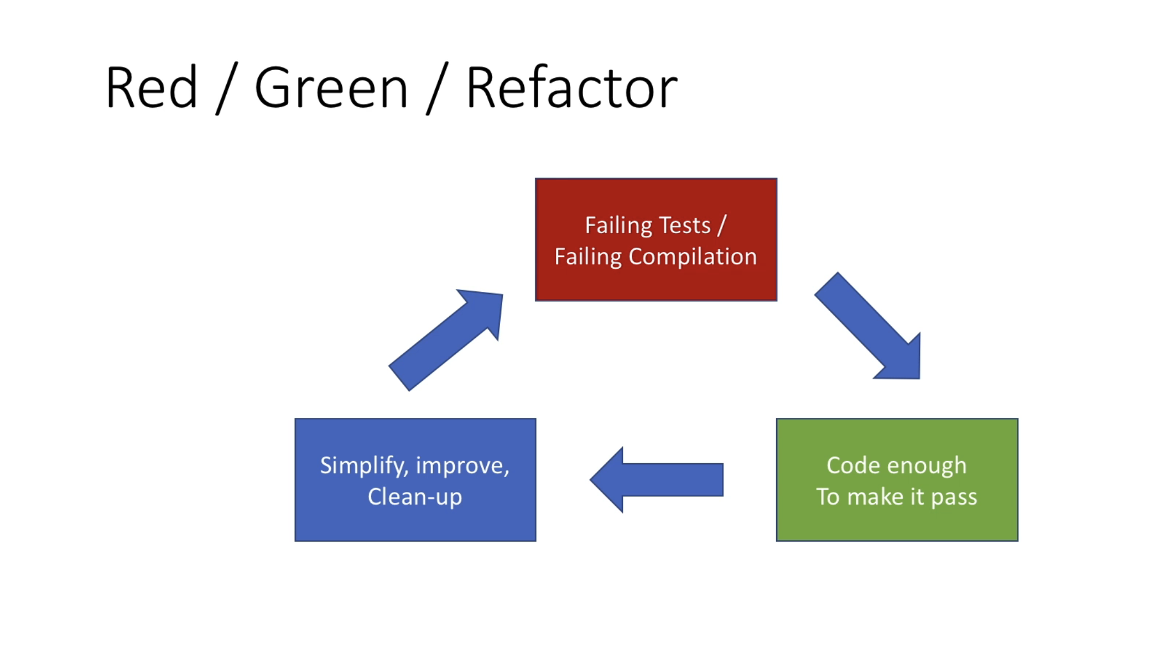

So red green refactor, as you've been saying, we start with failing tests or even code that doesn't yet compile because bits of it are missing from that.

We then move to doing just enough coding to make those tests go green.

Then we look at any possible improvements, any possible clean up or simplification we can make in order

to keep things nice and ready to repeat the process and add more features, more requirements and go around that circle.

**The refactoring is really important.**

If as you go along, your code doesn't stay simple and clean, then it becomes increasingly difficult

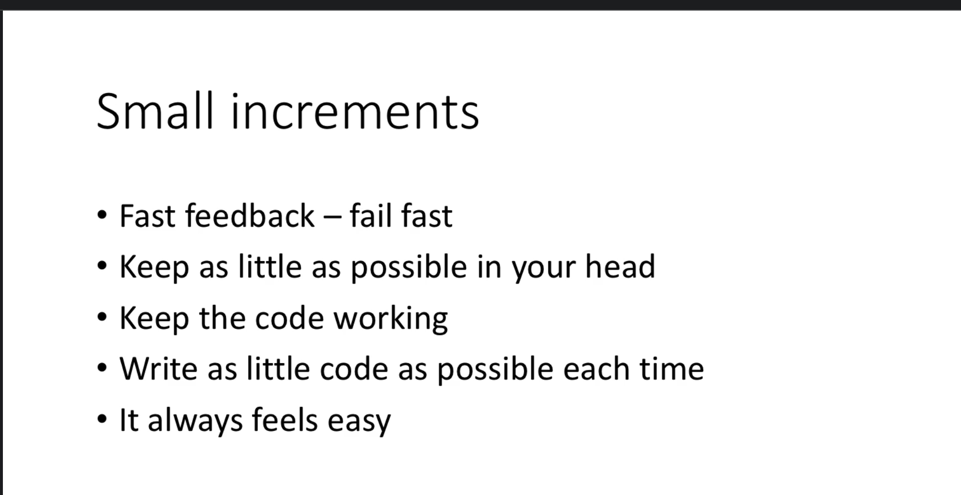

We've been talking about working in small increments.

Working in small increments means that you get fast feedback on what you're doing.

You get to fail fast, which means you can go back and try things differently.

If it isn't working.

Working in small increments means you're keeping as little as possible in your head and having a lot more to focus on rather than trying to worry about the whole problem.

You're just doing a **tiny slice**, which is **much easier**.

You keep the code within your workspace **working as long as possible**.

And all the examples we've been doing, things have only been failing for a few seconds at a time,

which again means you're always near to completion or at least a completion of what you've started so

far.

Writing as little codes as possible each time is what enables that to happen.

The point of this process is it always feels easy, even a big problem when one put through this process

is always made out of very, very easy steps.

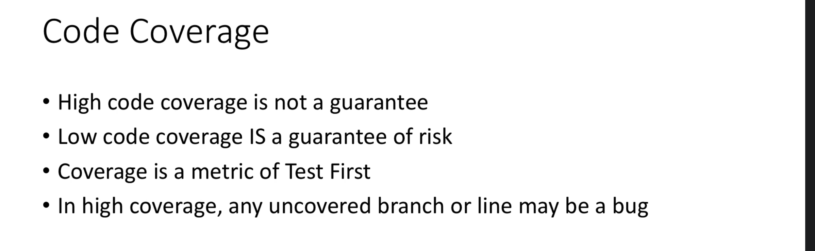

We talked about code coverage and I've been looking at it through the examples so far.

Now, high code coverage is not a guarantee that your code is awesome and we can do everything.

Your test can still be quite naive.

Your code can still be incomplete.

However, low code coverage is a guarantee that you have some risks in your project.

Coverage, therefore, is a metric of how much you're following the process, how much you're doing.

Test first, because if you are only writing code because some test needs it in order to pass, then

your coverage will naturally be very, very high in a high coverage situation there.

For one thing, he discovers that any uncovered branch or line of the code, anything that's read on

your coverage **report could actually be a bug.**

It might represent something that you either wrote unnecessarily or where you thought a test needed

it.

But the test wasn't testing what you thought it was.

And the code isn't quite operating the way you thought it would as well.

And so having high coverage can be **a marvelous feedback loop** to show you what's going on.

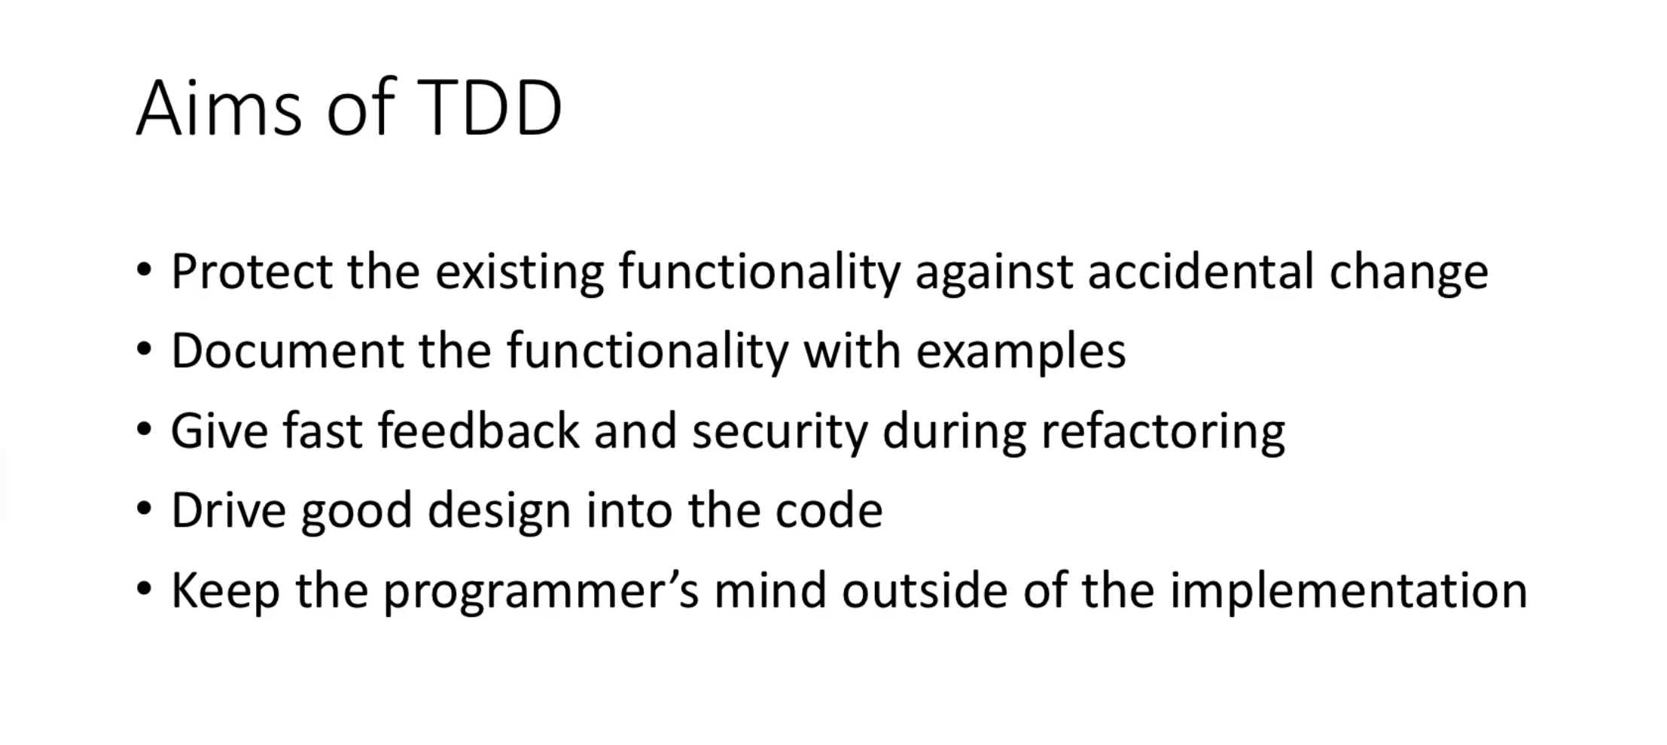

It's worth pointing out why we're trying to do TDD at all in the first place.

One of the obvious answers is that it protects the functionality of made against accidental change is

the equivalent of running regression testing all the time.

And the more frequently you run it, the more protection that seems to give you an extra benefit, though,

is it documents the functionality you have with worked examples with our LaPier example, for instance,

we were looking at different types of LaPier or different types of year and showing how the algorithm

had to account, how to handle those different situations.

And so somebody coming along can see it by example, as well as looking at how the algorithm actually

works.

Having TDD gives us fast feedback during refactoring and gives you a security against whether one refactoring

or another has just broken everything.

And I deliberately made that happen in some of the examples so you could see how easy it is and how

the tests themselves kind of point to where the problem likely is.

One of the main aims of TDD, from my point of view, is to drive good design into the code.

You become a client of your own code when you're writing its tests.

That means you try and make it as easy and as clean to use as possible by writing something that would

use it from the outside and then fulfilling that that contract when you come to implement it.

One of the key advantages of TDD, though, is that it keeps your mind as a programmer outside of the

implementation.

So you're getting that big picture view to make well-rounded, clean and reliable code.

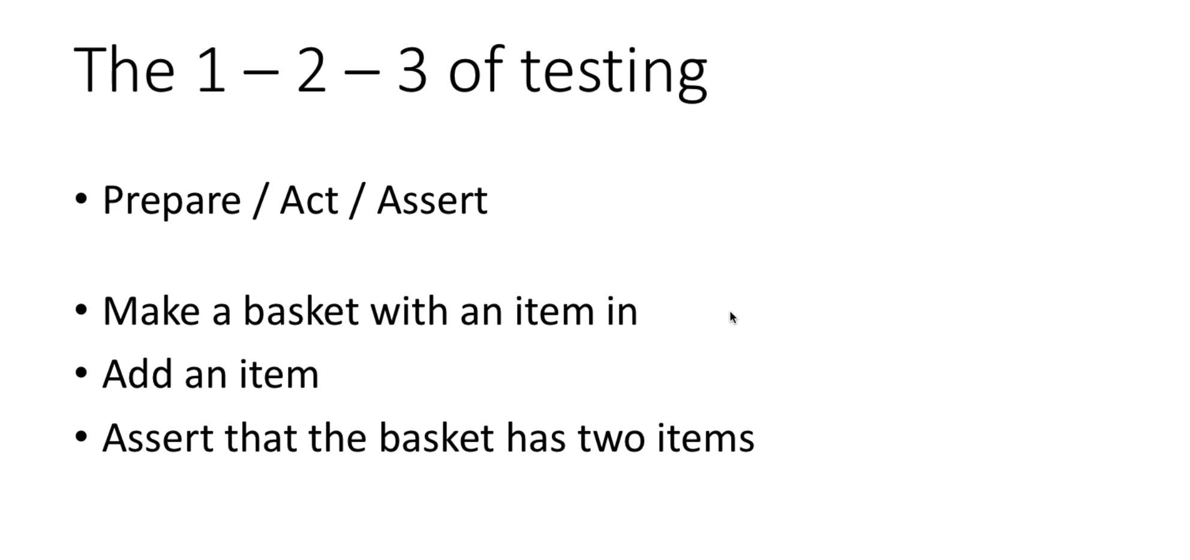

Testing is leap year and then asserting the outcome of that action.

Is it true?

Is it false?

Let's translate, prepare, act, assert into the sort of code you might write in the test case.

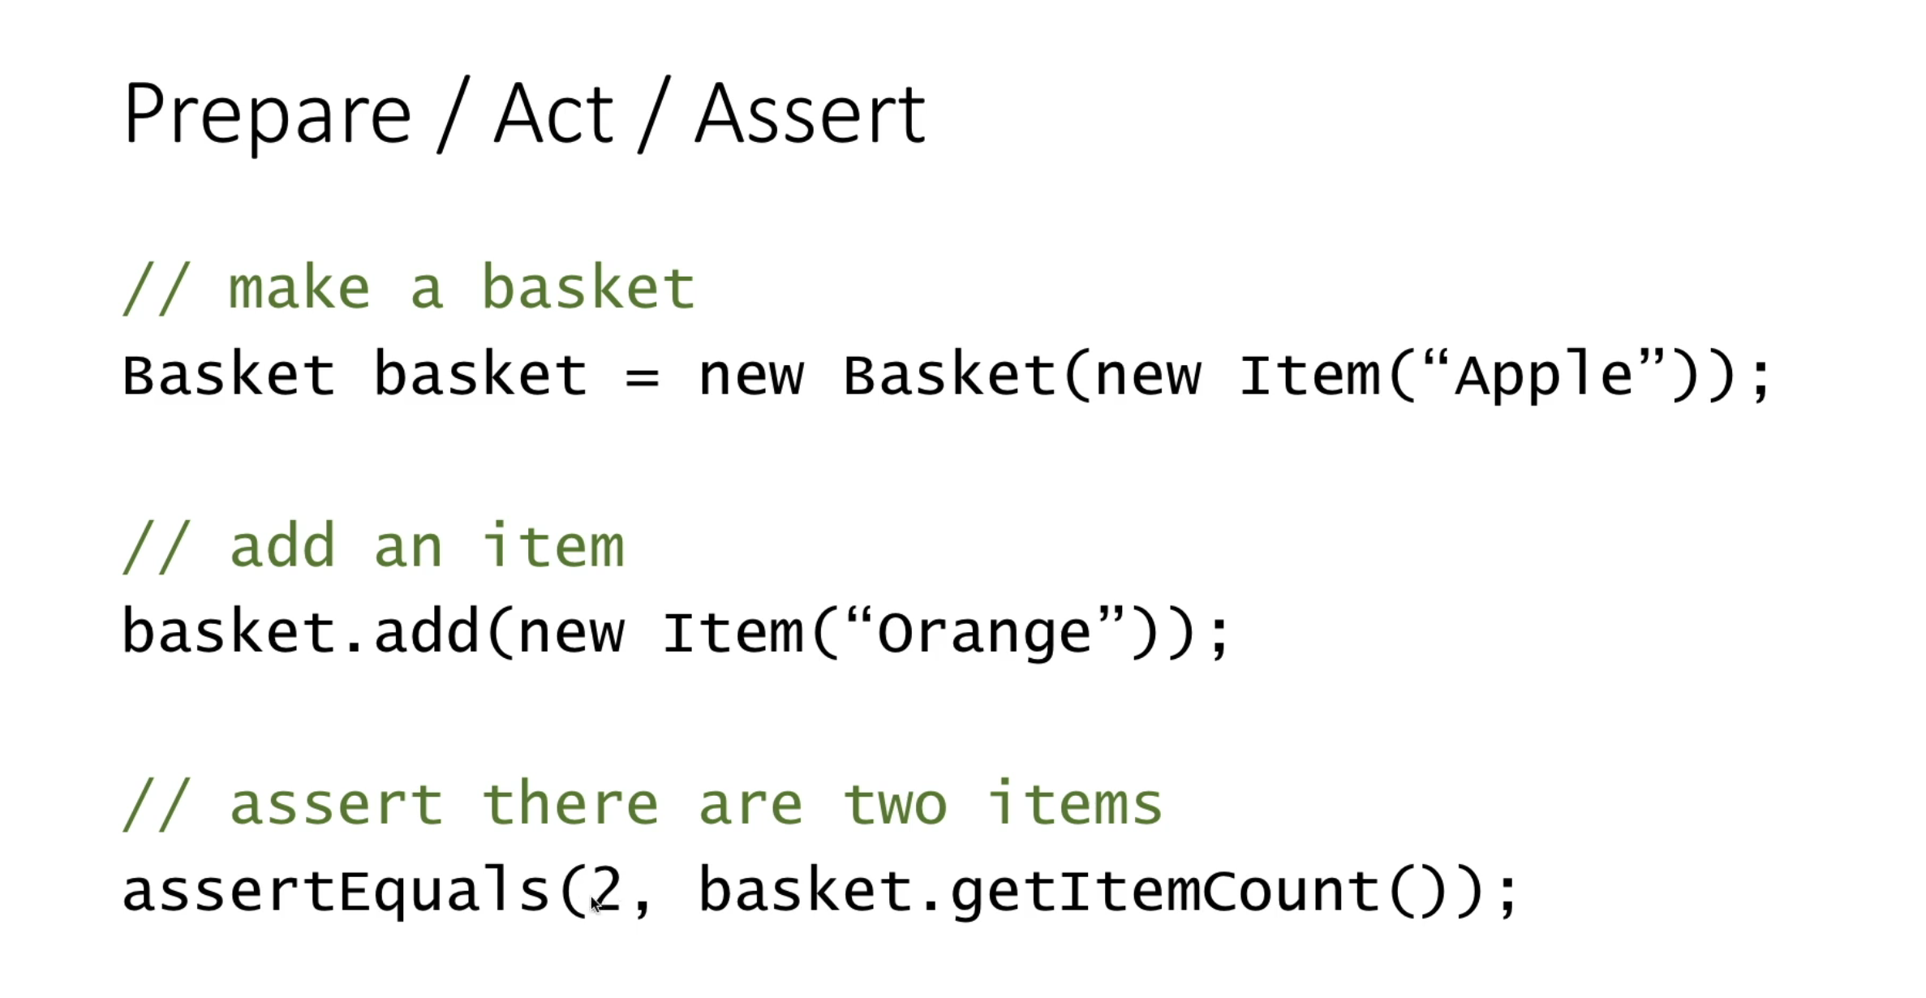

So for the prepare bit, make a basket.

We might create a new instance of something in the act bit as an item we might call a method on the

thing we've we've just instantiated.

And in this part we'd use one of J units assertion methods to check the result of something.

In this case, check that the answer is to when we call basket dot get item count.

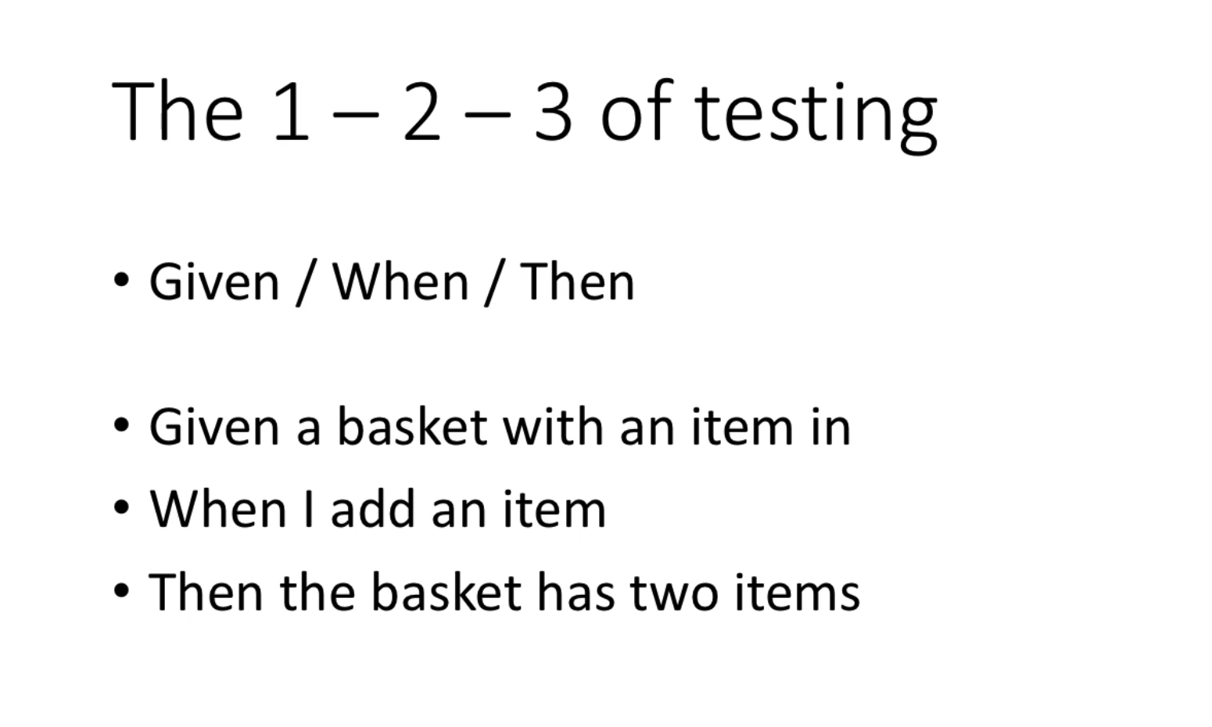

More recently, the BDD style of testing has been popular and that comes up with a an alternative description

for the one, two, three, which is given when.

Then let's just look at that basket example in this light.

So given the basket with an item in, when I add an item then the basket has two items.

This is more declarative, whereas the Prepare Act assert is quite imperative.

Do this, do that, do the other.

This one slightly more roundabout.

It says, given the situation then when such and such happens, this would be the outcome.

This is a lot more easy for people in the and the requirements and specification world to understand.

And I think this is a more modern style.

Let's look at that in code terms.

So given the basket well, turns out with create one when I do something describing the adding of something

and then then this is the expected outcome is again describing the assertion.

And this style I think, again, makes for much cleaner to read testing.

And it's sometimes useful to call out the given when and then when you do that, that process.

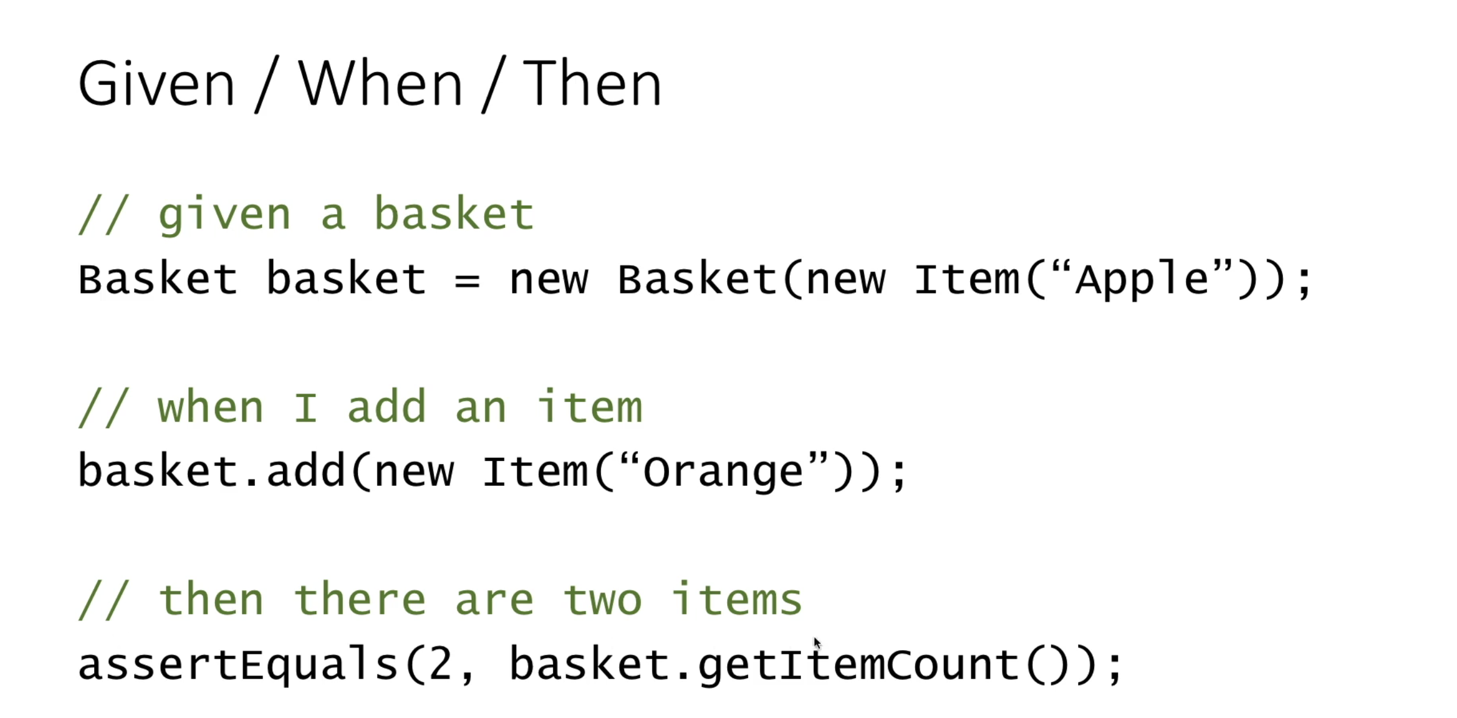

So the one theory of testing is a really good thing to have very clear in your mind, because it can

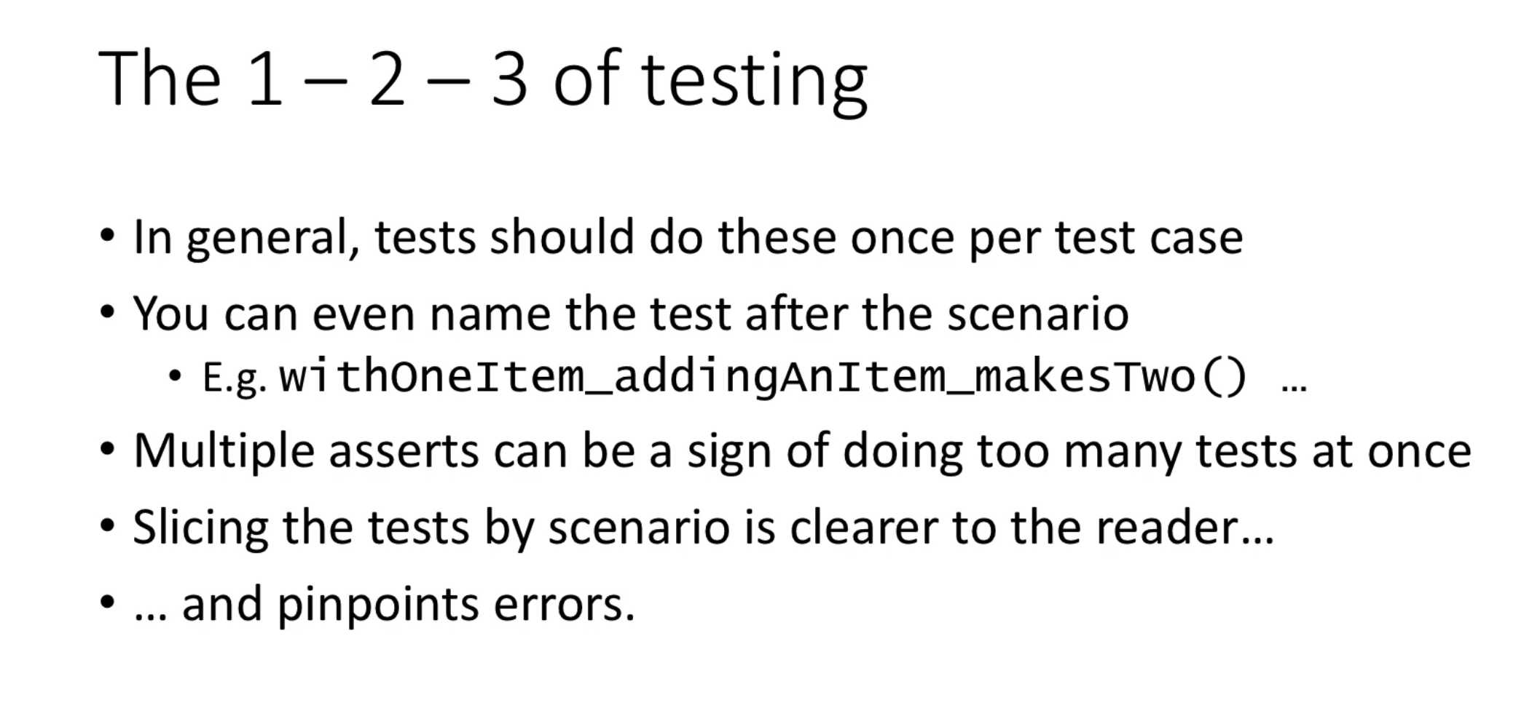

help you understand how to structure your tests in general, a test case to do one of these one of this

round of one, two, three per test case.

In fact, you might even want to name the test after that very scenario.

It's testing with one item, adding an item makes to that sort of thing.

If you have multiple asserts within the same test case, that might be a sign you're trying to do more

than one of these rounds in the same place.

It's possible that the only way to identify the correct outcome of something is to put three assertions

in to make sure that all elements of it are right.

But equally, it could be that you have some sort of composite test and you're not doing the one, two,

three.

You're kind of getting yourself up to 15 or something.

Slicing your tests by scenario makes it much clearer to the reader what that test is, is proving what

that test is describing.

But more importantly, when you slice your tests by scenario using this straightforward one, two,

three, when there are errors, the tests that failed really pinpoints what the particular error is.

That's just occurred with your latest code change.

**Deeper Example Word Count:**

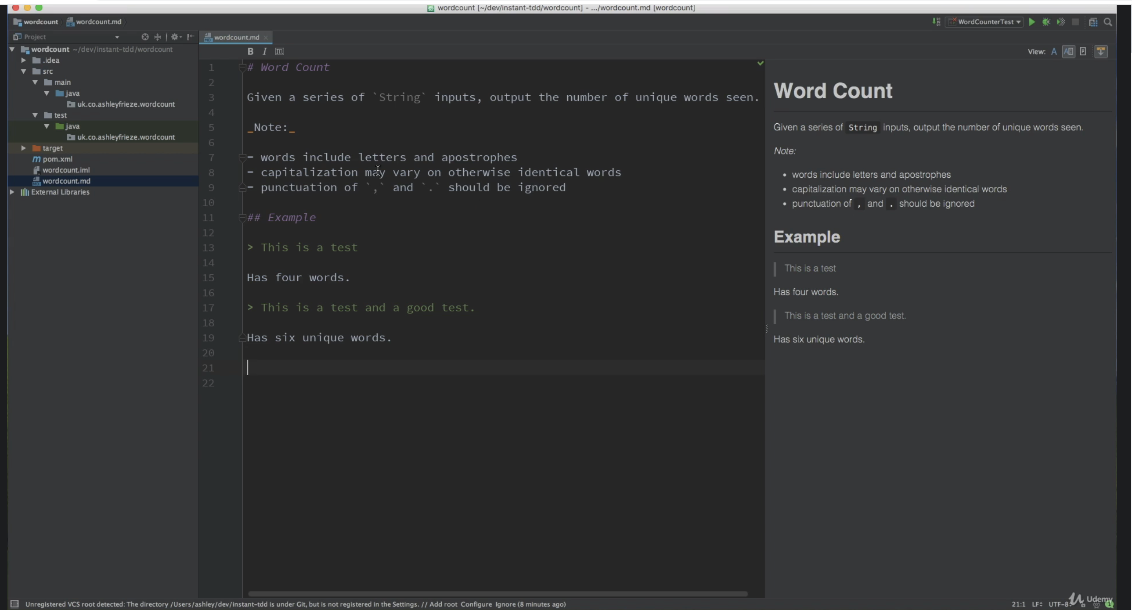

The previous examples we've looked at have been relatively simple, and it's now time to look at something

more complicated, where we'll take a larger idea and try to develop it, test first, growing the code

out of small increments.

The specification for this particular problem is a word counter.

It should be able to receive string inputs and output, the unique number of words it has seen.

Let's have a look at what the input might contain.

It may have letters or letter words with apostrophes in.

There may be a difference in capitalization on what would be identical words.

And so capital t the bus is normal.

There have to be treated as the same word and words will be separated by, of course, spaces, but

also some sort of punctuation characters.

So for example, if you took this is a test, you'd expect it to output for words.

Whereas if this is a longer example, which has got two repeated words, it has six unique words and

so on.

Now, the temptation in a situation like this is to write a really big and to end test and then try

and bang out an algorithm that can fulfill that test case.

But that can be quite a lot to do in one go and it's kind of going against the process we've talked

about.

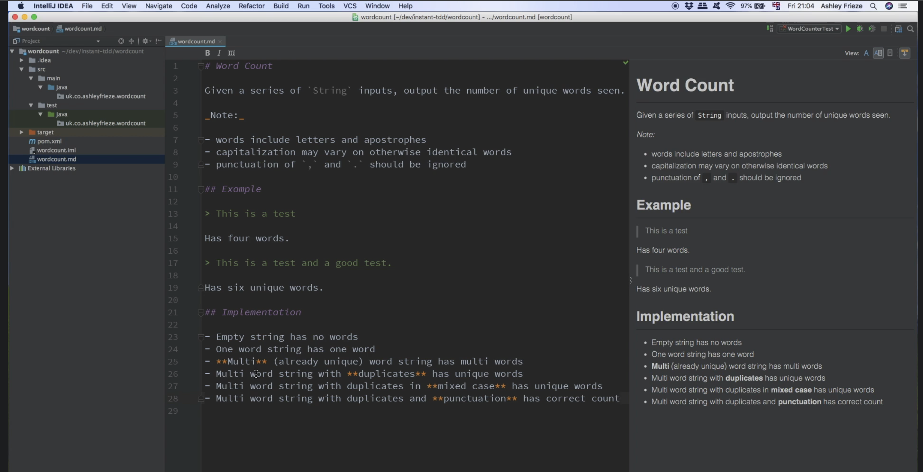

**So one way to approach it is to break the problem down into a series of incremental steps.**

So here's how I'm going to approach it this time around to start out with trying to process an **empty string**, know the algorithm to just handle empty strings is going to be really easy then **strings only with one word.**

Let's make it work for that.

**And then a piece of the time, try and grow it until it can do the whole thing.**

**What's useful about this is that we learn more about the problem and come up with more ideas for tests**

**and edge cases if we focus on starting very, very small.**

So let's dive right in and create the class that is going to be the home to the algorithm.

The word cancer.

And as we've done before, let's then immediately create a test for that class, which luckily the idea

is given the rather sensible name to.

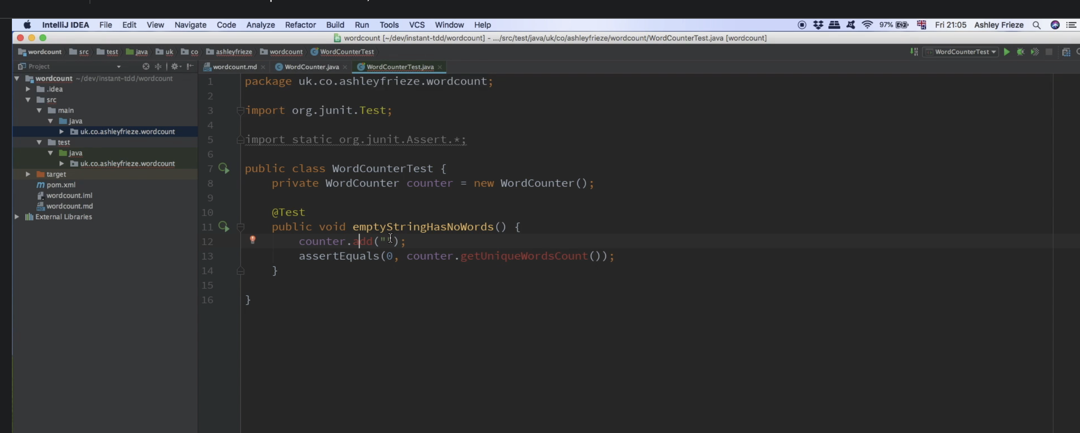

**First test case,**

empty string has no words so far, so good we don't have a word counts are really here, but **let's imagine**

**how we might use it, I guess, because it can handle multiple inputs**.

We want to somehow call counter dot and in this case with an empty string.

And we want to somehow assert that the number of words that it has got in the scene so far is zero countertop

get unique words.

Accounts say seems like a reasonable bit, a bit of code, we haven't got an instance of counter here,

and I'm going to put that in this part of the tests just for some for a change.

Lovely, thank you to the idea for filling that in for me, and the reason I'm going to do that is that

**every individual test method is going to be run in the fresh instance of the test class**.

**And there's no need to repeat the new in every single method, if we can put it there at the at the top of the class.**

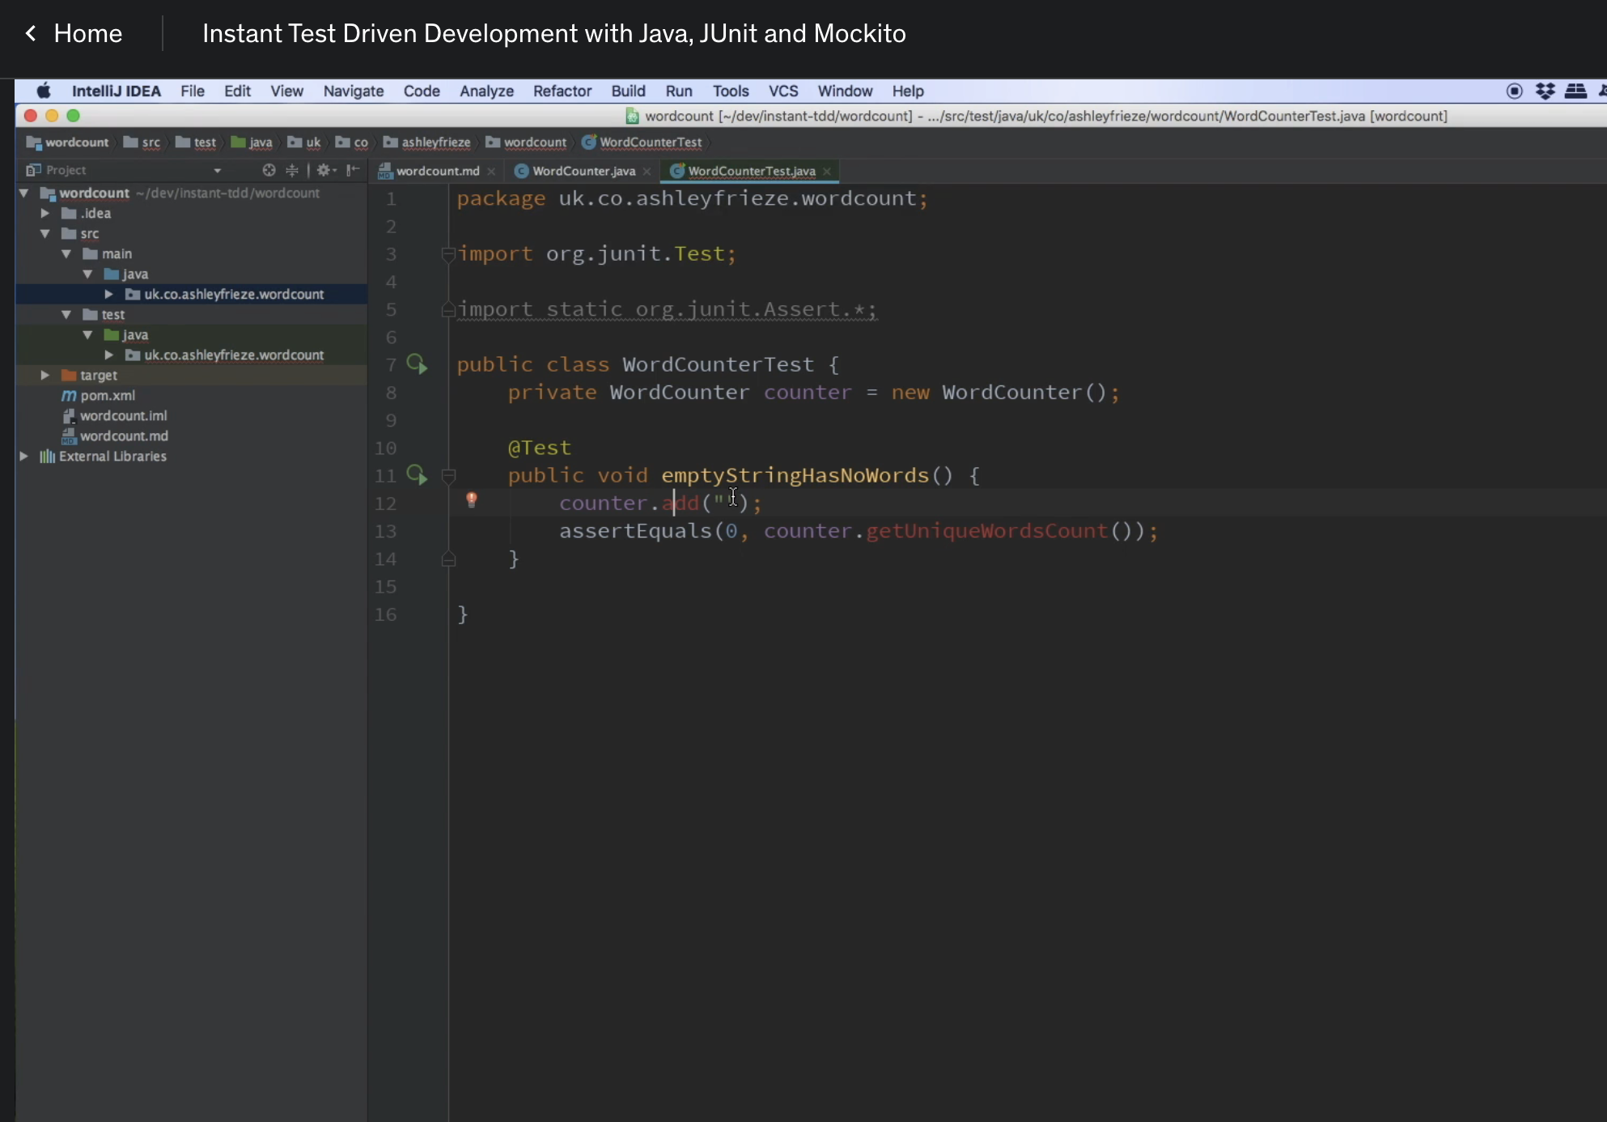

So in this case, there's going to be a counter ad, nothing to it.

And that and then we assert that it doesn't think there are any words.

Let's start creating some of the methods that so far don't exist that that are needed by this test driving

in the design into the work class.

So there's going to be an method which I guess is going to take a sentence seems to be a reasonable

name for it.

And there's also going to be a get unique words count, which is a method which for the moment is going

to return minus one just so we can see our initial test failing, just to make sure it's really doing

something that's run our test.

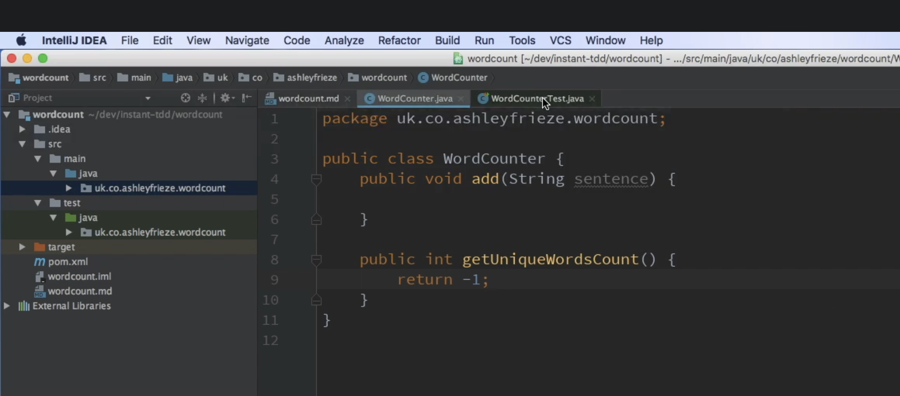

And so far, we should see that we have a non-working algorithm and of course, we do write, the algorithm

fails.

So now we're going to try and make the word count to pass just for that simple situation.

I think probably the easiest way to do this isn't words so far equals zero.

That's.

Make it return there.

There we go.

Seems like a bit of implementation, let's run our test and see if it passes.

It does so we now have a a world council, which, so long as it's only given empty strings, will successfully

tell the client that there are no words in them.

That's not the whole specification, but it's not a bad start.

So let's look at what we're going to do now.

We're going to move on to having one word strings with one word.

Now, this is a very naive implementation.

It's very naive testing, but we know that.

And it's OK.

We've got the extra increments in our list so we can feel OK about it.

So a single word string has one word count.

And hello.

So equals one.

Lovely will run all our tests again.

And in this case.

Oh, dear, the single word use case doesn't pass well, of course it doesn't.

We need to somehow put some sort of implementation in.

So let's increment our word so far that we'll do it.

We run all the tests.

Well, now a single word has has one word, single, single word, string has one word that's succeeding,

but the empty string has no words, is failing because clearly we have to treat empty strings, especially.

So if not, sentence is empty.

Seems to now filter out empty strings, run that.

Great.

Now, what would happen if we decided to use two single word strings, so to a single word string?

Have two words.

Separate use case, let's create another add, and in this case, we're going to keep them unique so

that we're not we're not upsetting the specification with these tests and we'll run that and see what

happens.

Is our algorithm sufficient enough to tot up the toss up are the correct number as it's failed on the

screen?

It's failed because the actual is, too.

And in fact, we should have expected there to be two.

That was an incorrect test rather than the incorrect algorithm.

It's OK.

We're seeing it from both sides that now passes, as indeed do all of the tests.

Great.

So as far as our strategy is concerned, we've certainly nailed the idea of empty strings and one word

strings.

But clearly, this is not this is not good enough.

So we need to somehow drive into this the idea of strings that genuinely contain multiple words.

And that next increment is going to be a little bit harder.

But we've least nailed down some of the other edge cases on the way there.

So let's have a think about that increment.

Alti word string has a correct word counts, so we're not going to put in a string which has duplicated

words because that's harder about one to three.

That's a string that contains three words.

And we would therefore assert that that should contain.

That number of words, that's what we think it should do, we know it won't do it, but let's see that

test fail and let's see it fail for the right reason before we go into anything else.

So we were expecting three, the actual this one, this algorithm so far doesn't cut it right in here.

Now, let's see what we're going to do.

I think probably string dot splits would be our friend.

So how about.

Words so far, let's have a look at make words so far, plus equal sentence stock splits with a space

dot net worth.

So we split it up, see how many pieces there are, and that will give us the right answer.

Let's see what that does run.

Great.

That seems to have nailed nailed the problem really, really well, and so long as people feed in things

that have unique words, then this will absolutely count them correctly.

I'm starting to worry about whether that will really cope with really cope with multiple inputs.

So let's just let's give it a go.

Let's double check that.

It can cope with a multiple input.

I expect there to be six six across those, let's just run that test on its own just to see if it succeeds

or fails.

Yep, that's great.

And I'd also expect that this could cope with the edge case where spaced out.

When someone's decided to stick a whole bunch of white space kind of around the place and hope that

it could, it could handle that, let's see whether it actually does when we do that.

This is an edge case that occurred to me whilst I was just looking at that particular particular detail

as see what happened.

Oh, dear.

Spaced out string really upsets that algorithm.

So somehow we're going to have to make this algorithm a little bit cleaner when it comes to splitting

the string.

So we found even in that subset of the problem, we found an edge case because we were not having to

look at something harder.

OK, so I think the first thing we probably want to do is trim string before we split it, not Timit

trimming it something else.

OK, that may help.

Let's see what happens to the test when we trim the string first.

OK, it's gone from 11 down to seven, that's still too many.

Luckily, intelligence is quite handy.

It shows us what the inputs to split is.

Split actually takes a regex.

So what it really is, is something like.

White space.

Let's see if that helps.

Yes, it does.

So I took the edges off, which was giving us lots of false splits, and I also said split on any combination

of whitespace, which is absolutely great.

So at this stage, we've now got a rather sophisticated algorithm with all of its edge cases up to the

multi but unique words being counted by the class.

However, we haven't really so far haven't even thought how we would deal with duplicates, and I think

it's now time for us to refactor what we have to use a different method that may also be able to handle

duplicates.

So, first of all, let's put the the duplicate example in.

It's probably quite straightforward to test.

Input with duplicates.

Counts on the individual.

Says.

I am three nines, it should consider that there's only one unique word that.

We'll stay on that.

No, it thinks there are three because it's very naive.

So let's go and have a look at how we might make it, the DUP, which is the issue here.

So I think one experiment we could do because we've dealt with the.

Is empty when the one experiment we could do is to see whether we can somehow do something that allows

us to take is empty away as well.

So I think what we're probably looking for here to cut to the chase is a set.

Words so far, new, fresh set, everyone's favorite set.

There we go, the idea filling in some of the blanks there for me.

Just bring in the imports.

And clearly the word the words seen so far would be the size of the set.

The set can only contain unique items.

But we're now going to have to work on this bit of code here to make it use the set.

And if the sentence is not empty, what we want to do is we want to split the.

The sentence, so let's do a four straight word in.

Every.

Thing from there, and we want to words so far docked at what?

That's pretty good intelligence has some other ideas as to how to implement this using some Java eight

pieces, but let's see what our tests make of it when we run it through their.

Oh, we've nailed it.

Look at that so that that does a really, really good job of of breaking that, breaking that up and

passing all of our tests.

So let's have a look at our requirements.

So multiple words with duplicates has unique words.

Absolutely nailed it.

You'll notice that the transformation we made was was quite nice, actually, that a lot of the code

was already there from simpler, early examples.

And we did something that happens quite a lot within testing, which is you've started with like a one

case and then you're trying to grow it to an end case.

So I replaced something as simple as a counter with a collection.

I replace something that was just counting a length with something that used a for loop on that on that

same output and just had a small change to the function that was returning.

The count this so far, if I look at it from the purposes of refactoring, I could say, well, it's

missing javadoc and maybe actually there's probably something I'd recommend doing here for the sake

of refactoring.

I don't really like seeing things nested when you can do something like invert the logic and return

early.

Thus keeping the function much more linear and maybe easier to read, let's just double check that,

that's all passing when we run the tests and indeed.

That there it is, it's working.

So how much more difficult is it to cover the extra use cases?

We've got mixed case and we've got punctuation, so let's try the mixed case use case.

What's that even look like?

In fact, what's going on?

So let's imagine we have the same example here.

So let's imagine that someone's made that nine lower case and this one I've been shouting in upper case,

that's still just the word nine.

And it's they treated the different words because as far as the strings are concerned, they're different

to each other.

So how hard a problem might that be to solve?

I'll give you a clue about that.

Hard.

Make it all one case and then that problem goes away, so a big tick to this.

And now finally, let's try and deal with the punctuation issue.

So what is the punctuation issue?

I've obviously spotted this at the point of thinking about this problem.

What would it look like in practice?

So consider this situation nine.

And let's look at nine, ten, full stop and then let's look at nine, come at 10, 11.

There are only three words there.

However, we know that the way our algorithm works, putting stuff up by space, that nine dot is what

it's going to get.

It's going to get 10 dot.

It's going to get nine commer despite everything else we've done.

Let's pretend that it's going to work perfectly and assert what we wish would happen, which is that

can see three words run all of our tests again.

And boom, it thinks there are six words because of that punctuation problem that we kind of knew was

going to happen.

So how are we going to deal with that?

Well, Reg, access can really help you in this situation.

And in this case, I think I just need to put dot and comma in there.

So any amount of whitespace or.

A dot and a comma.

Let's see if that helps us have a funny feeling, it won't actually.

But what's really nice about this situation is that it allows we've got some experimentation going on.

So, in fact, the reason it doesn't quite work is that you get a mixture of whitespace and commerce.

So let's do this and that.

So this is now going to take space characters, dots and commas and have any quantity of those.

Let's see if that works better.

Yes, it does.

Right.

So the next question.

Have we met the entire requirement?

I think we have.

Have we got codes that is refactored to a point where we like it?

Again, I think we are pretty, pretty close to that and do we have tests that are explaining step by

step, everything that's needed and have been helping us build the algorithm?

Well, hopefully you feel that way as well.

So these are the moves you make when you're doing TDD.

And it's strange to see how what we thought we might have to build really developed quite differently

once we started from the simpler use case.

I'm not sure I would have gone and written this code exactly this way, putting exactly these things

in these places.

But it grew rather neatly and organically from those requirements, and I'm quite pleased with the end

result.

So that's TTD done on a larger example.